GOVERNOR BIOGRAPHIES
NEIL McGRATH - External Governor and Chair of the Board
Committees: Finance & Resources; Remuneration; Search & Governance

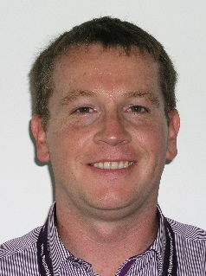
Neil McGrath is currently Deputy Chief Executive at Halton Housing Trust Group, the largest registered provider of social housing in Halton.
After studying for his A Levels, Neil joined the finance team at North British Housing Association (NBHA) in Preston in 1987 where he trained and qualified as an accountant in 1996.
In 1999 Neil left NBHA and worked for 20 months at the Department for Work and Pensions (DWP) in Blackpool, before rejoining the social housing sector as Assistant Director of Finance at West Pennine Housing Association in Oldham in 2001.
Neil joined Halton Housing Trust as Director of Resources in 2005 and, working as part of the Executive Directors Team, successfully oversaw the transfer of homes from Halton Borough Council to HHT later that year.
Neil is married with 3 children. He tries to keep fit by going to the gym and playing golf.

MICHELE BACON - External Governor & Vice-Chair
Committees: Quality & Standards (Chair); Remuneration; Search & Governance

Michele is a qualified teacher and until her retirement after 35 years in August 2018, she was the Lead Principal of the Wade Deacon Trust.

With a Masters degree in Educational Leadership and Management, NPQH, Michele was a National Leader of Education and led the Wade Deacon Teaching School. Within that role she always placed great emphasis on supporting others to ensure the very best outcomes for young people.

Michele was seconded to work for the Knowsley Commission to help support the drive for improvement in educational outcomes across the Borough. This involved me working with a network of secondary schools, providing advice and devising/supporting professional development programmes for headteachers and senior leaders. Her experience includes leading a number of schools in challenging circumstance and Michele continues to be an active practitioner in supporting school improvement across all phases.

KAREN BANKS - External Governor & Vice-Chair
Committees: Audit (Chair); Quality & Standards; Remuneration; Search & Governance

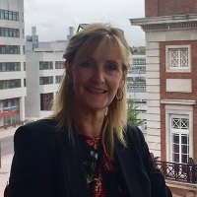
Karen is currently Director of Strategic Change at the University of Liverpool. She has previously worked in a number of universities, (Coventry, Sheffield Hallam, and Manchester Metropolitan), where she has undertaken a range of roles. She provides mentorship to individuals enrolled on the Association of University Administrator’s Post Graduate Certificate in HE Management. Karen’s qualifications are an MSc in Management Studies, and Post Graduate Diplomas in Policy Studies and Advanced Employment Law.

Experienced in organisational governance, within the context of her day job, and also as a former member of the Board of Directors of a Manchester based Social Housing Association, where she sat on the main board, chaired the operations committee, and led a review of governance.

Karen is based in Northwich where she lives with a teenage daughter, and Labrador puppy. Most spare time is devoted to long muddy walks with the dog.

Supporting access to high quality education for all, is a real passion, given the transformative impact it has for both individuals and society.

VALERIE ALLEN, MBE - External Governor
Committees: Audit
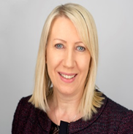
Married with two children and a grand-daughter, Val was awarded an MBE in 2015 for services to the community and business in Halton and Warrington.
Val runs an engineering company in Widnes, established in 1982 employing 28 local people. She was appointed to the Board of Halton Chamber of Commerce in 2009 and is currently the Chair.
Formerly a trustee of a charity (Compassion in Action), which provides help and support to those in need, she continues as Patron to advise the Chief Executive on
the day to day governance and development of the organisation.
Being involved with both business and the community, Val brings a wealth of knowledge and experience to the Board and is keen to work with the College and to encourage local businesses to become more involved with young people.
Prior to being appointed to the Board, she enrolled at the College on a Business and Management Foundation Degree course, graduating in 2016 from Edge Hill University, gaining a BSc (Hons) Degree in Business and Management. She is now studying for a Masters Degree in Business at Edge Hill University.
Val was elected as a councillor for the Borough of Warrington in 2021.

JAYNE EDWARDS - External Governor Committees:
Audit; Quality & Standards
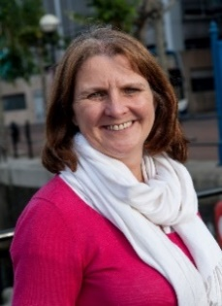
Jayne is an experienced senior manager and director, with a broad commercial and operational experience. She has a lifelong interest in education and training and is passionate about developing people and helping them succeed.
Until her retirement in 2019 Jayne was the Director of the Catalyst Science Discovery Centre and Museum in Widnes, responsible for a major transformation of its facilities. Prior to that she held management positions in several further education and skills providers and was latterly Managing Director of Cogent Skills Services, which supports the science industries with their skills and development needs.
Apart from education, Jayne’s interests centre around travel, geography, geology, charity fund-raising and walking the family’s dog, Bella.

TOM McINERNEY - External Governor
Committees: Quality & Standards
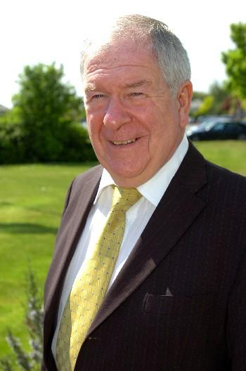
Tom is the Halton Borough Councillor for Halton View in Widnes, Cheshire. He is the Executive Board Member for Children, Education & Social Care.
A former bus driver, Tom has served the local community for many years and was mayor of Halton in 2015. His other interests include membership of the Liverpool City Region Child Poverty & Life Chances Commission.

MARY MURPHY - Principal & Chief Executive
Committees: Finance & Resources; Search & Governance
Mary was appointed as Principal from September 2013, having been Vice-Principal (A Level) at Riverside College from July 2009 and the Head of A Level and Pre-Advanced Studies at Runshaw College prior to that.
In her earlier career Mary worked at Pendleton College as Head of Pre-Advanced Studies and as a Teacher of Leisure & Tourism. Mary has a background in the leisure industry and progressed rapidly from graduate trainee to general manager.

LYNN PEGLER - External Governor
Lynn Pegler brings expertise in communications and marketing to the board.
She started her career as a newspaper journalist in Cumbria and then worked as a communications manager/press officer for the Ministry of Defence (Army),
the Central Office of Information and British Waterways.
She has run her own public relations consultancy Pegler Communications since 2009. She holds a post-graduate diploma in Public Relations from the Charter Institute of Public Relations, an MA in Creative Writing from Manchester Metropolitan University
and BSc (Hons) degree in Geography from
Birmingham University. She also holds a teaching diploma in drama from the London Academy of Music and Dramatic Art (LAMDA) and professional qualifications from the National Council for the Training of Journalists.
Lynn enjoys serving as Vice-Chair of the Halton Chamber of Commerce, as a Deputy Lord Lieutenant of Cheshire and being festival manager of Weaver Words, Frodsham Literature Festival.
She is married with two children, and in her spare time acts and directs theatrical productions with Kingsley Players and plays the violin in the Lancashire Chamber Orchestra. Her first book of poetry was published in 2016.

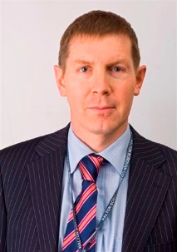
WESLEY ROURKE - External Governor
Committees: Finance & Resources; Remuneration; Search & Governance (Chair)
Wesley is an Operational Director for Economy, Enterprise and Property at Halton Borough Council.
After reading Modern Languages and Literature at university he worked for Rochdale, Bolton and Wigan Councils before joining Halton Borough Council in 2003. Over a twenty-five-year period he has managed and delivered a wide range of externally funded regeneration programmes.
During his career, Wesley has also enjoyed working with colleges in the North West to co-ordinate and deliver European trans-national projects, supporting students to obtain environmental sustainability qualifications in France and Germany respectively. He also helped a college in Lviv, Ukraine to set up a one stop ‘shop’ for business.
In 2000 he completed an MBA. In recent years he has participated in Local Government’s Academy for Executive Leadership.
In his current role at Halton he is responsible for bringing forward and implementing the Borough’s major physical development sites; managing the Council’s property and strategic assets; coordinating and acting upon the Borough’s inward investment and business enquiries; encouraging and supporting businesses to expand; developing and delivering initiatives which create, secure and safeguard jobs in the Borough; and, the provision of a wide range of adult and family learning courses across the Borough.
Wesley’s number one obsession is food - eating and preparing it…He also lists travel as a major interest.
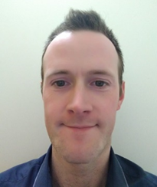
CHRIS SIKORSKI - Staff Governor
Committees: Finance & Resources
Chris Sikorski is Senior Officer, Quality at Riverside and Cronton Colleges. Before joining the College in 2005 Chris Graduated from the University of Salford with a first class honours BSc in Business, working for a pharmaceutical company as a work placement and then MBNA bank straight after university for nine months.
He has worked in the Quality department of the College both pre and post-merger and still does to this day. In addition, Chris works two mornings per week in the information services department to further improve inter-departmental communication and College wide data production and reports.
Chris is married with a young son and is a keen runner.

SUSAN SMITH - External Governor
Committees: Finance & Resources; Remuneration (Chair)
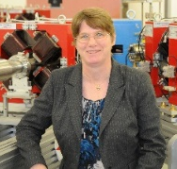
As graduate of Glasgow University, Susan started at Daresbury Laboratory as a physicist in 1985, working on the development of particle accelerators for light sources. Later Susan’s role changed to leading the accelerator physics input from Daresbury Laboratory for a range science projects, including future particle physics facilities such as those at CERN in Switzerland.
Susan retired from her role as Director of Accelerator Science and Technology Centre at Daresbury in 2020. As Head of Daresbury Laboratory she worked strategically with the joint venture partners, Halton Borough Council and Langtree,
in developing the Science & Innovation Campus.
Susan is passionate about ensuring that those working and living locally to the Campus can benefit from their proximity to an exciting “Big Science” research facility, which aims to grow 10,000 high value jobs over the next 20 years at Daresbury. As such she acts as an ambassador for the facility.
Outside of the science world, Susan is a keen golfer and table-tennis player.

RYAN TURNER - Staff Governor
Committees: Quality & Standards

Ryan is the College’s Head of Higher Education.

